**Methods**

**Site Selection**

We launched a community science initiative in the greater St. Catharines and Niagara region called Crowkemon Go (www.crowkemon.weebly.com) in spring 2022. Community members were invited to report the location of crows spotted during the spring months to locate areas with a high likelihood of finding crows. In total, the community recorded 221 crow sightings using Crowkemon Go between January and May 2022. From April-May 2022, we visited potential observation sites and baited them with whole peanuts to attract crows and reinforce an association of food with these locations. We limited data collection to the summer months (June-September 2022) when nestlings are fledging, and groups are less tightly bound by the territory immediately surrounding the nest. One site was selected for recurrent sampling (Fairview Park, 43°10'57.4"N 79°14'44.9"W). We also visited areas with many crow sightings for opportunistic sampling, as the presence of crows was not guaranteed at other potential recurrent sampling locations (fig. A1).

**Field observation**

Data collection was performed during the 2-3 hours following sunrise (approx. 6-9AM). No sampling was performed when it was raining or during adverse weather (e.g., thunderstorm or heatwave). Upon arriving at the recurrent sampling location, a Nikon D5300 camera with a 70-300mm Nikkor lens was set up on a tripod a minimum of 15m away from a concrete pad (predetermined bait location). If crows were already foraging in the area, we would begin recording immediately and not bait the site. If not, an observer approached and visibly dropped 30g of Cheez-Its, then returned to the camera. If crows were on-site, recording would start immediately, whereas if the crows were absent, a crow-caller would be used for 20 minutes (1 5s. call per min, 5 mins on, 5 mins off) to attract them. We would then begin recording upon the arrival of the crows and recorded up to maximum of 20 minutes. The recording was stopped if the crows vacated the area for longer than 5 minutes and we remained in the area for 10 minutes post-departure in case the crows returned. If the crows returned, we would continue the trial.For opportunistic sampling, we looked for crows using Crowkemon Go as a guide. If we found crows that were already foraging, we would set up in the same manner as for recurrent sampling and did not bait the site. Conversely, if the crows were not already foraging, we would bait the site as we did for recurrent sampling.

The presence of a sentinel, whether heard or seen, was announced verbally by the observer during the recording, and group size and disturbances (e.g., pedestrians, pets, vehicles) were also verbally noted. For each location, we classified the type of environment using St. Catharine municipal zoning maps. The ‘generalized environment’, a factor used for all subsequent analyses, was categorized by labeling all types of green spaces as “green”, and all types of commercial area as “commercial” (Table A1). Disturbance frequency was calculated by dividing the number of disturbances by the overall recorded duration. Group size was binned into two categories: small ($≤$ 4) and large ($>$ 5)

**Video Analysis**

For video analyses, we used the Behavioral Observation Research Interactive Software (BORIS v.8.9.4) [1]. We classified behaviors as either “foraging” or “alert”, with “alert” being the behavior of most vigilance, and “foraging” the behavior of least vigilance due to the inability of an individual to effectively scan their surroundings while pecking at or looking for food on the ground. The behaviors were defined by the position of the focal individual’s head and body posture (Table A2). We recorded the duration of bouts of each behavior for every individual and bouts of less than 0.01s. were removed. Since not all bouts of movement were recorded in their entirety, “moving” behavior was excluded from these analyses. We then calculated the proportion of time spent performing each behavior. Behaviours were recorded separately for if a sentinel was present or not. Therefore, the same individual could have two observations if it foraged or was alert in both the presence and absence of a sentinel.

In addition to these behaviors, we also recorded the number of pecks (handling food with their beaks for the purpose of eating it) to quantify foraging effort. The peck rate (per min) was calculated for every individual by dividing the total number of pecks at food performed by the total duration of “foraging” behavior. Individuals that did not forage were excluded.

**Statistical Analysis**

All statistical analysis was performed in the R environment (v.4.2.2; R Core Team 2022) [2]. We first ran a chi-squared test to determine if the generalized environment, the group size, or the disturbance frequency affected the likelihood of a sentinel being present in our videos.

To determine the effects of generalized environment and sentinel presence on the proportion of time foragers allocated to each behavior, we used the “lm” function in the R Stats package [2] to fit a linear model using behavior type, sentinel presence and generalized environment as fixed effects.

To determine the effects of generalized environment and the presence of a sentinel on the duration of bouts of all behaviors, we used the function “rlmer” from the “robustlmm” package [3] to fit a robust linear mixed model on the log-transformed duration of bouts with behavior type, sentinel presence, generalized environment, group size, and bait presence as fixed factors, the disturbance frequency (per min) as a fixed effect and the individual ID as a random effect. We then post-hoc fitted robust linear mixed models on each behavior to determine the effects of sentinel presence and generalized environment on each behavior. The duration of bouts was log-transformed to normalize the distribution of bout duration.

To determine the effects of sentinel presence and generalized environment on foraging rate, we used the function “rlmer” from the “robustlmm” package [3] to fit a robust linear mixed model on the peck rates using sentinel presence, generalized environment, group size, and bait presence as fixed factors, the disturbance frequency (per min) as a fixed effect, and the individual ID as a random effect.

Finally, we counted the number of transitions from each behavior to determine the effects of sentinel presence and generalized environment on the frequency of each transition type. Using the “glmer” function from the “lme4” package [4], we fitted a generalized linear mixed model using a Poisson distribution on the number of occurrences of each transition. Sentinel presence, generalized environment, and bait presence were used as fixed factors, the disturbance frequency (per min) was used as a fixed effect, and the total number of transitions performed by the individual was used as a random effect in the model.

Post hoc estimated marginal means tests were performed as appropriate using the “emmeans” function from the “emmeans” package [5]. P-values were corrected using the “fdr” method, and the results were averaged over the unused categorical factors.

**Results**

**Sentinel presence**

Neither the generalized environment (χ2 = 0.1221515, df = 1, p = 0.727; fig. 1), group size (χ2 = 0.2481203, df = 1, p = 0.618; fig. A2), or the disturbance frequency (χ2 = 2.032678, df = 2, p = 0.362; fig. A2) significantly affected the likelihood of a sentinel being present.

**Allocation of time to each behavior**

We made 64 observations across 25 videos. 81 observations were made for the proportion data. Crows allocated similar proportions of time to foraging and vigilance ( $\hat{β}$ = 0.0263, SE = 0.0236, t-stat = 1.16, p = 0.248; fig. 2, tab. 1), and neither the presence of a sentinel ( $\hat{β}$ = -0.0335, SE = 0.0234, t-stat = -1.4314, p = 0.154; fig. 2, tab. 1) or the generalized environment ( $\hat{β}$ = 0.0336, SE = 0.0230, t-stat = 1.4625, p = 0.146; fig. 2, tab. 1) had an effect on the proportion of time allocated to either alert or foraging behavior.

**Duration of bouts of all behaviors**

In total, 5091 bouts were recorded, of which 2110 bouts were of alert behavior, and 1787 bouts were of “foraging” behavior. 1173 bouts of movement and 21 observations of duration less than 0.01s were removed. Bouts of alertness and foraging were significantly different ( $\hat{β}$ = -0.2557, SE = 0.0511, t-stat = -5.002, p = <0.001; fig. 3, 4, tab. 2), with bouts of alertness being significantly shorter than bouts of vigilance. Sentinel presence increased the duration of all bouts significantly ( $\hat{β}$ = 0.1974, SE = 0.0720, t-stat = 2.7406, p = 0.006; fig. 3,4, tab. 2). Bouts of all behaviors in green areas were significantly longer than those in commercial areas ( $\hat{β}$ = 0.3534, SE = 0.0873, t-stat = 4.0482, p = <0.001; fig. 3,4, tab. 2). The interaction between generalized environment and sentinel presence had a significant effect ( $\hat{β}$ = -0.2524, SE = 0.0882, t-stat = -2.8630, p = 0.004; fig. 3,4, tab. 2). The interaction between behavior type and generalized environment was also significant ( $\hat{β}$ = -0.2023, SE = 0.0537, t-stat = -3.7690, p = <0.001; fig. 3,4, tab. 2). Lastly, the disturbance frequency had a significant effect on the duration of all bouts ( $\hat{β}$ = -0.0878, SE = 0.0295, t-stat = -2.9748, p = 0.003; fig. 4, A3, tab. 2), with bout duration decreasing as disturbance frequency increased.

Post-hoc pairwise testing revealed significant differences in the duration of bouts of all behaviors. In commercial areas, the presence of a sentinel increased the duration of bouts ( $\hat{β}$ = -0.157, SE = 0.0653, z-ratio = -2.402, p = 0.0489; tab. 3). In the absence of a sentinel, foragers in green areas had longer bouts ( $\hat{β}$ = -0.252, SE = 0.0821, z-ratio = -3.074, p = 0.0127; tab. 3). Foragers in commercial areas and in the absence of a sentinel had marginally shorter bouts than in green areas and in the presence of a sentinel ( $\hat{β}$ = -0.157, SE = 0.0720, z-ratio = -2.117, p = 0.0589; tab. 3). All other comparisons were not significant (p < 0.3430; tab. 3)

**Duration of bouts of “foraging” behavior**

Generalized environment had a significant effect on the duration of bouts of foraging behavior, with bouts being longer in green areas ( $\hat{β}$ = 0.3826, SE = 0.0778, t-stat = 4.9194, p = <0.001; fig. 3, 5, tab. 2). Sentinel presence had no significant effect on the duration of bouts of foraging ( $\hat{β}$ = 0.0919, SE = 0.0718, t-stat = 1.2799, p = 0.201; fig. 3, 5, tab. 2). The interaction between generalized environment and sentinel presence was also significant ( $\hat{β}$ = -0.2272, SE = 0.0914, t-stat = -2.4849, p = 0.013; fig. 3, 5, tab. 2). Larger groups had significantly longer bouts of foraging behavior ( $\hat{β}$ = -0.1519, SE = 0.0684, t-stat = -2.2205, p = 0.026; fig. 5, 6, tab. 2). The presence of bait decreased the duration of foraging bouts ( $\hat{β}$ = -0.1385, SE = 0.0697, t-stat = -1.9885, p = 0.047; fig 5, A4, tab. 2). Increasing disturbance frequency significantly decreased the duration of foraging bouts ( $\hat{β}$ = -0.1075, SE = 0.0301, t-stat = -3.5664, p = <0.001; fig. 5, 7, tab. 2).

Post hoc tests revealed significant differences in the duration of bouts of foraging behavior. In the absence of a sentinel, foragers in green areas had significantly longer bouts of foraging behavior than in commercial areas ( $\hat{β}$ = -0.3826, SE = 0.0778, z-ratio = -4.919, p < 0.0001; fig. 3, tab. 4). In the presence of a sentinel, foragers in green areas also had significantly longer bouts of foraging behavior than in commercial areas ( $\hat{β}$ = -0.1555, SE = 0.0665, z-ratio = -2.337, p = 0.0291; fig. 3, tab. 4). The presence of a sentinel had no significant effect on the duration of bouts of foraging behavior when in commercial areas ( $\hat{β}$ = -0.0919, SE = 0.0718, z-ratio = -1.280, p = 0.2006; fig. 3, tab. 4). In the presence of a sentinel and in green areas, foragers had a significantly longer bouts of foraging behavior than in the absence of a sentinel and in commercial areas ( $\hat{β}$ = -0.2474, SE = 0.0662, z-ratio = -3.738, p = 0.0006; fig. 3, tab. 4). When in the absence of a sentinel and in green areas, foragers also had significantly longer bouts of foraging behavior than in the presence of a sentinel and in commercial areas ( $\hat{β}$ = -0.2907, SE = 0.0870, z-ratio = -3.340, p = 0.0017; fig. 3, tab. 4). In green areas, foragers in the presence of a sentinel had marginally shorter bouts of foraging behavior than in the absence of a sentinel ( $\hat{β}$ = 0.1352, SE = 0.0684, z-ratio = 1.977, p = 0.0577; fig. 3, tab. 4).

**Duration of bouts of “alert” behavior**

In contrast to foraging behavior, sentinel behavior, generalized environment, group size, bait presence and disturbance frequency had no significant effect on the duration of bouts of alert behavior (p < 0.141; tab. 2). However, the interaction between sentinel behavior and generalized environment was significant ( $\hat{β}$ = -0.2736, SE = 0.1352, t-stat = -2.0243, p = 0.043; fig. 8, tab. 2). Post hoc pairwise t-tests revealed no significant differences in the duration of bouts of alert behavior.

**Foraging rate**

We calculated the peck rate (per min) for 81 observations. Two observations were removed as the individual did not perform any foraging behavior. Neither the presence of a sentinel nor the generalized environment alone had a significant effect on the peck rate of foragers (p > 0.702; fig. 9, 10, tab. 5). Peck rate increased significantly with disturbance frequency ( $\hat{β}$ = 5.29, t-stat = 2.312, p = 0.021; fig. 11, tab. 5). The interaction between generalized environment and disturbance frequency also significantly affected peck rate ( $\hat{β}$ = 16.15, t-stat = 3.046, p = 0.002; fig. 9, 10, tab. 5). Lastly, the presence of bait significantly increased the peck rate of foragers ( $\hat{β}$ = 13.99, t-stat = 2.231, p = 0.020; fig. A5, tab. 5).

**Pathway analysis**

Transitions from foraging to alert behavior were significantly affected by generalized environment (IRR = 2.1154, SE = 0.0.7689, z-stat = 2.0615, p = 0.039; fig. 12, tab. 6), disturbance frequency (IRR = 0.7281, SE = 0.1085, z-stat = -2.1301, p = 0.033; fig. 13, tab. 6), and the interaction between generalized environment and sentinel presence (IRR = 0.1992, SE = 0.0975, z-stat = -3.2976, p = 0.001; fig. 12, tab. 6).Transitions from foraging to pecking were significantly affected by the presence of bait, with more transitions occurring in the presence of bait (IRR = 1.7096, SE = 0.3843, z-stat = 2.3858, p = 0.017; fig. A5, tab. 6). All other factors did not affect this transition (p-value > 0.436; tab. 6). Transitions from pecking to alert behavior were similarly affected by the presence of bait, significantly increasing when bait was present (IRR = 2.2037, SE = 0.5378, z-stat = 3.2378, p = 0.001; fig. A5, tab. 6). All other factors did not affect this transition (p-value > 0.235; tab. 6). Transitions from alert to foraging behavior were not significantly affected by any factors, however, bait presence had a marginally significant effect (IRR = 1.5134, SE = 0.3506, z-stat = 1.7888, p = 0.074; fig. A5, tab. 6), increasing the number of transitions from head up to head down.

Post hoc testing on the number of transitions from foraging to alert behavior revealed significant differences. In green areas, individuals performed more transitions from foraging to alert behavior when in the presence of a sentinel ( $\hat{β}$ = -1.1237, SE = 0.3457, z-ratio = -3.2500, p = 0.0069; fig. 12, tab. 7). In the presence of a sentinel, individuals exhibited marginally more of the same transitions in green areas ( $\hat{β}$ = -0.7493, SE = 0.3635, z-ratio = -2.0615, p = 0.0785; fig. 12, tab. 7). However, in the absence of a sentinel, individuals exhibited marginally more transitions from foraging to alert behavior in commercial areas ( $\hat{β}$ = 0.8644, SE = 0.3722, z-ratio = 2.3214, p = 0.0608; fig. 12, tab. 7).

**References**

1. Friard O, Gamba M. 2016 BORIS: a free, versatile open-source event-logging software for video/audio coding and live observations. *Methods Ecol. Evol.* **7**, 1325–1330. (doi:10.1111/2041-210X.12584)

2. R Core Team. 2022 R: The R Project for Statistical Computing.

3. Koller M. 2016 robustlmm: An R Package for Robust Estimation of Linear Mixed-Effects Models. *J. Stat. Softw.* **75**, 1–24. (doi:10.18637/jss.v075.i06)

4. Bates D, Mächler M, Bolker B, Walker S. 2015 Fitting Linear Mixed-Effects Models Using lme4. *J. Stat. Softw.* **67**, 1–48. (doi:10.18637/jss.v067.i01)

5. Lenth RW. 2023 emmeans: Estimated Marginal Means, aka Least-Squares Means.

**Figures**

**Captions**

**Figure 1 :**

**Figure 2 :**

**Figure 3 :**

**Figure 4 :**

**Figure 5 :**

**Figure 6 :**

**Figure 7 :**

**Figure 8 :**

**Figure 9 :**

**Figure 10 :**

**Figure 11 :**

**Figure 12 :**

**Figure 13 :**

**Figure 1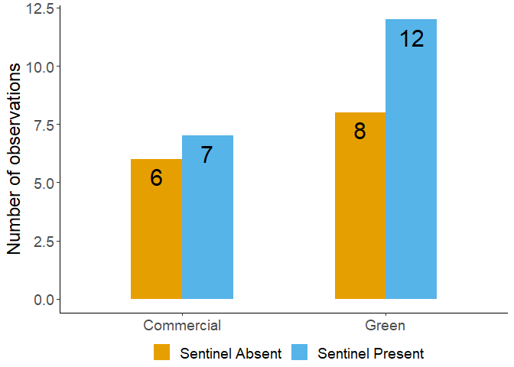

**Figure 3**

**Figure 4**

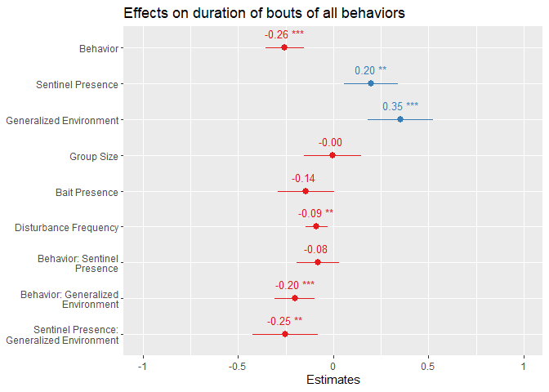

**Figure 5**

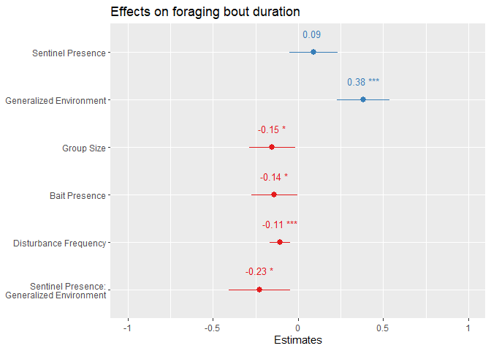

**Figure 6**

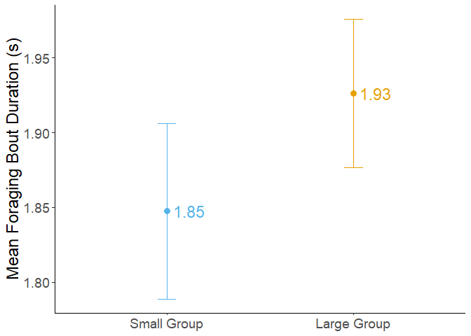

**Figure 7**

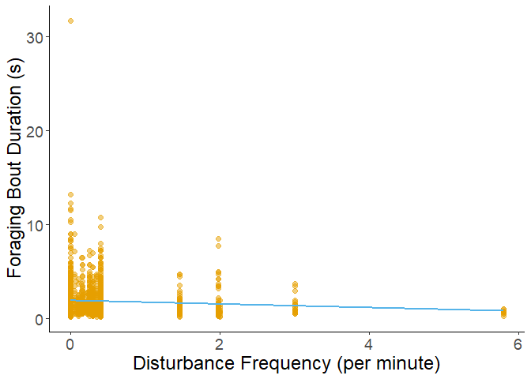

**Figure 8**

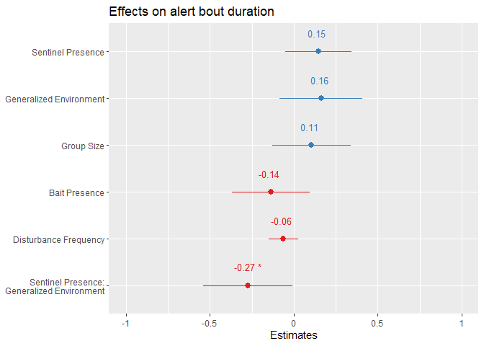

**Figure 9**

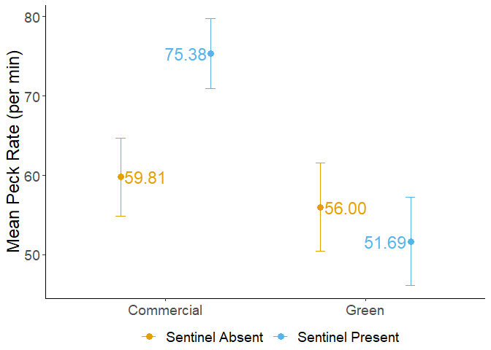

**Figure 10**

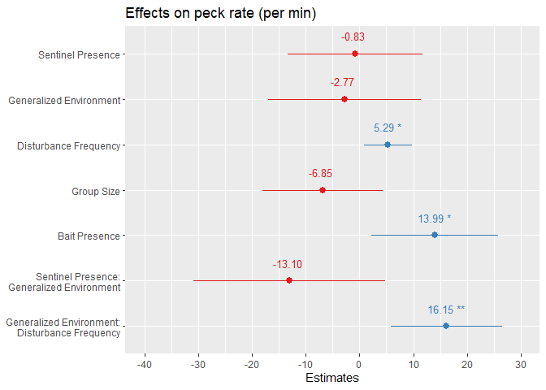

**Figure 11**

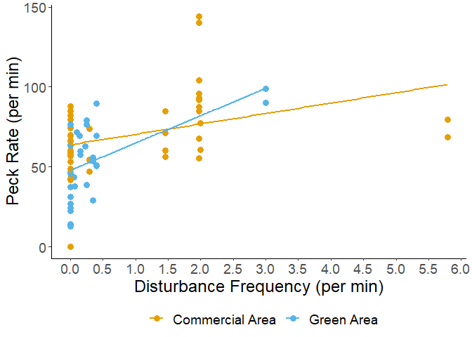

**Figure 12**

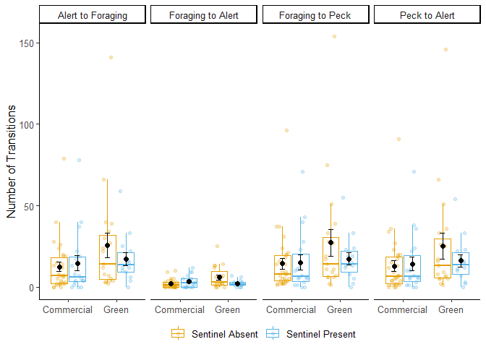

**Figure 13**

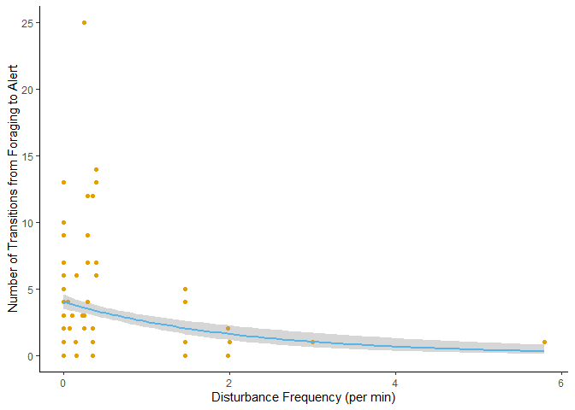

**Tables**

**Captions**

**Table 1:** Output summary table from the linear model fitted on the proportion of time allocated to each behavior. Neither the behavior, sentinel presence, or generalized environment significantly affected the allocation of time to each behavior. This suggests that foraging crows spend equal amounts of time performing each behavior, and that the allocation of time to each behavior remains relatively fixed across foraging events.

**Table 2:** Output summary tables of the robust linear mixed models fitted on the bouts of all behaviors (left), bouts of foraging behavior (center), and bouts of alert behavior (right). Bouts of all behaviors are significantly affected by the presence of a sentinel, generalized environment, disturbance frequency, the interaction between sentinel presence and generalized environment. More importantly, there was a significant effect of behavior, suggesting that the duration of bouts of foraging and alert behavior differed. The significant interaction between behavior and generalized environment further suggests that the differences in bout duration between the two behaviors is also affected by the foraging environment. Bouts of foraging behavior were significantly affected by all factors except sentinel presence, while bouts of alert behavior were significantly affected by the interaction of sentinel presence and generalized environment.

**Table 3:** Results of post hoc testing on the duration of bouts of all behaviors using estimated marginal means tests. The contrasts were between the two generalized environments, and the presence and absence of a sentinel to determine differences caused by the interaction between the factors. The duration of all bouts was significantly affected by the generalized environment in the absence of a sentinel. In commercial areas, the presence of a sentinel significantly affected the duration of bouts of all behaviors. A marginally significant difference in the bout duration of all behaviors was identified between foragers in commercial areas and in the absence of a sentinel, and foragers in green areas and in the presence of a sentinel.

**Table 4:** Results of post hoc testing on the duration of bouts of foraging behaviors using estimated marginal means tests. The contrasts were between the two generalized environments, and the presence and absence of a sentinel to determine differences caused by the interaction between the factors. The duration of foraging bouts was significantly affected by the generalized environment in the presence of a sentinel and absence of a sentinel. Generalized environment in the absence of a sentinel had a similar significant effect on the duration of bouts of foraging behavior. Sentinel presence in green areas had a marginally significant effect on the duration of bouts of foraging behavior. A significant difference in foraging bout duration was identified between foragers in commercial areas and in the absence of a sentinel, and foragers in green areas and in the presence of a sentinel.

**Table 5:** Output summary tables of the robust linear mixed models fitted on the peck rate (per min) of foragers. Disturbance frequency, bait presence, as well as the interaction between generalized environment and disturbance frequency had a significant effect on the peck rate of foragers.

**Table 6:** Output summary table from the generalized linear mixed model fitted on the number of transitions from one behavior to another. All transitions, except from foraging to alert behaviors, were significantly affected by the presence of bait. The transition from foraging to alert behavior was significantly affected by generalized environment, disturbance frequency, and the interaction between sentinel presence and generalized environment.

**Table 7:** Results of post hoc testing on the number of transitions from foraging to alert behaviors using estimated marginal means tests. The contrasts were between the two generalized environments, and the presence and absence of a sentinel to determine differences caused by the interaction between the factors. The generalized environment in the presence of a sentinel had a marginally significant effect. The generalized environment in the absence of a sentinel had a significant effect. The presence of a sentinel in green areas had a significant effect as well.

**Table 1**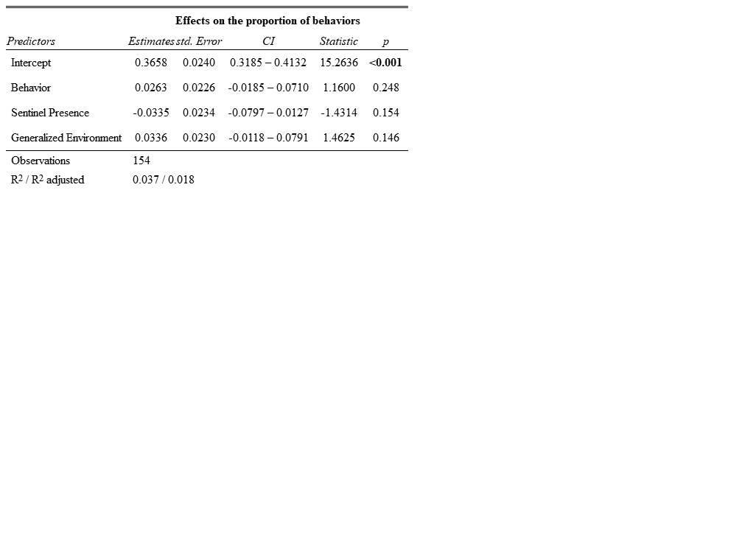

**Table 2**

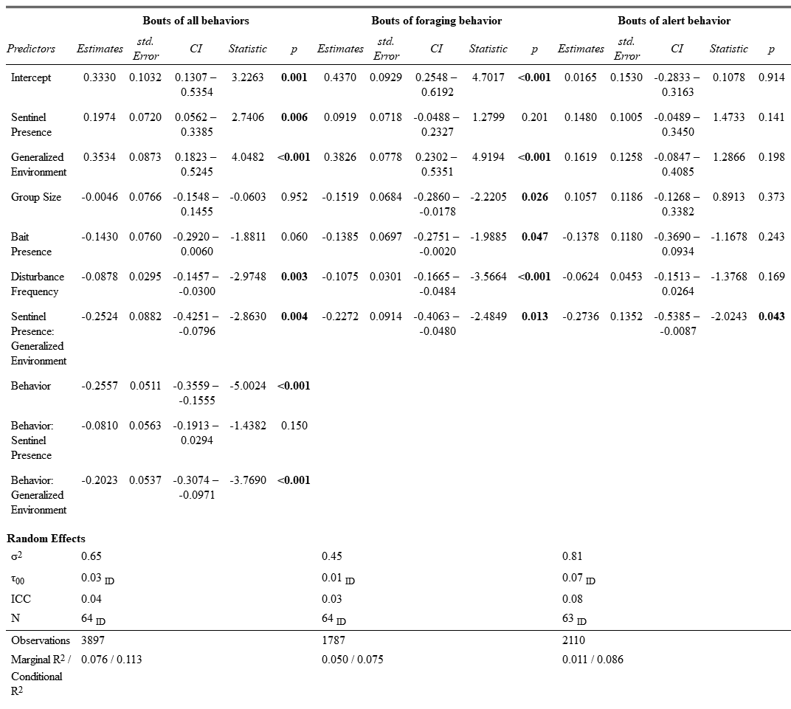

**Table 3**

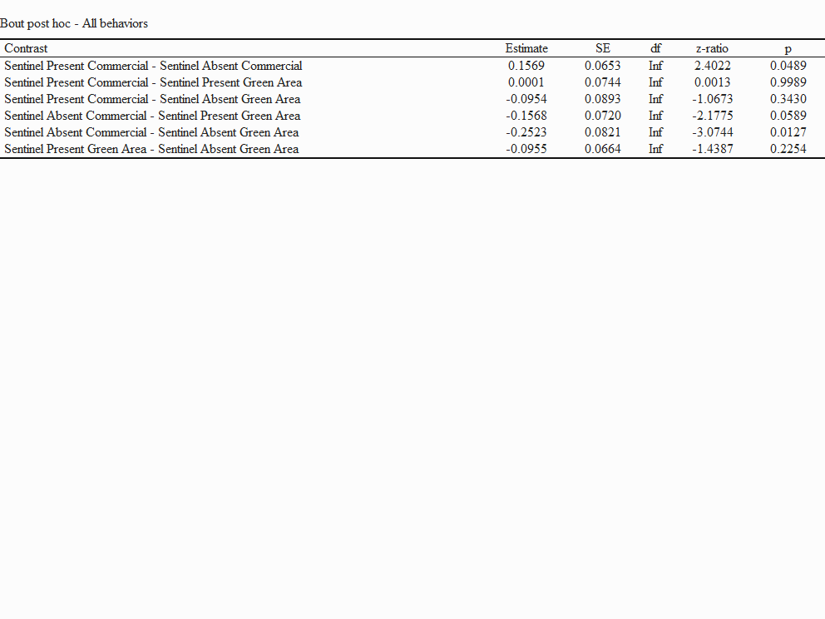

**Table 4**

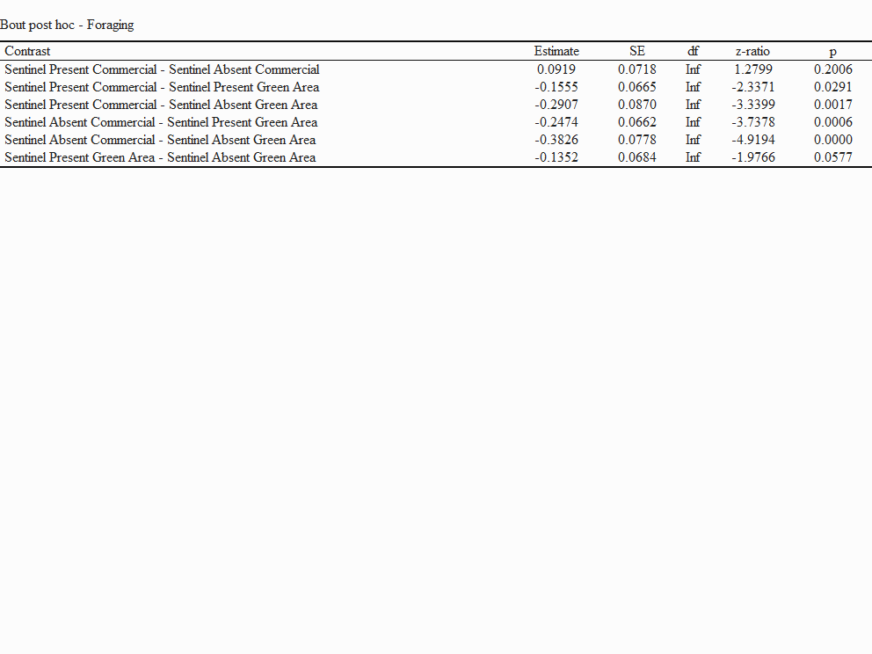

**Table 5**

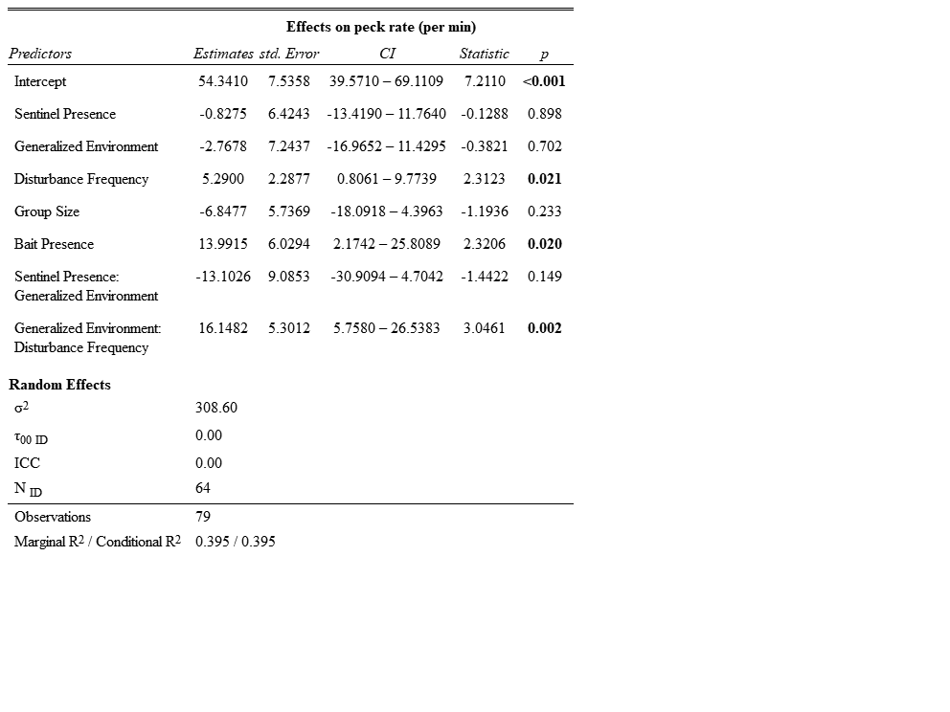

**Table 6**

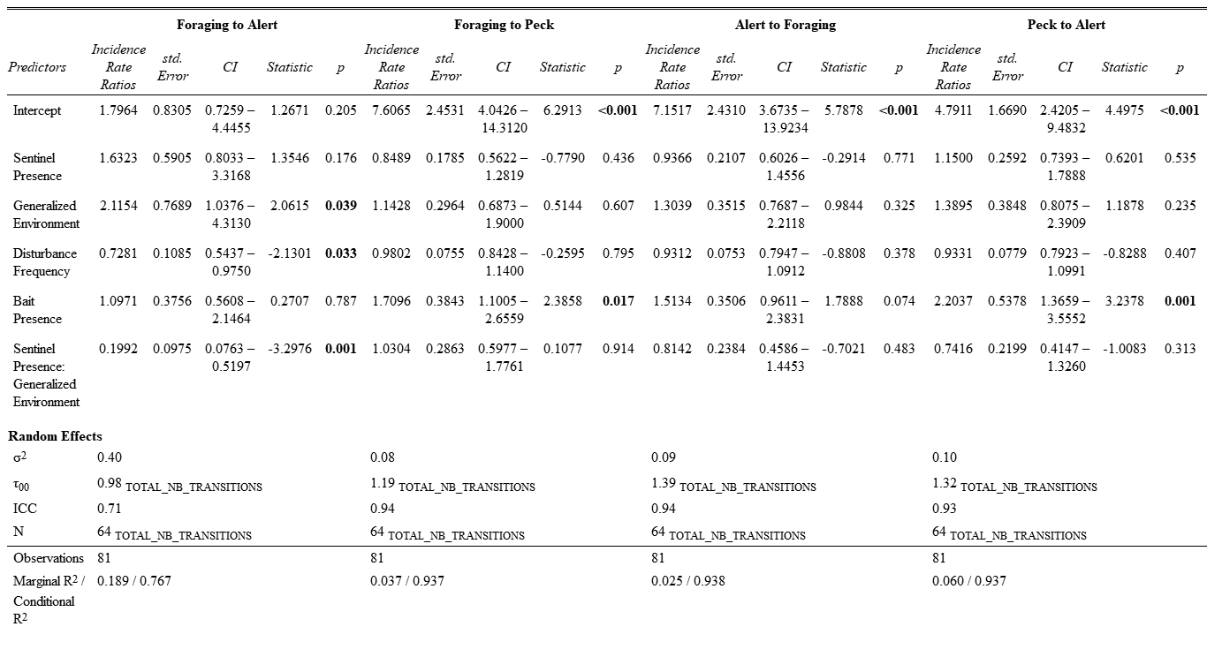

**Table 7**

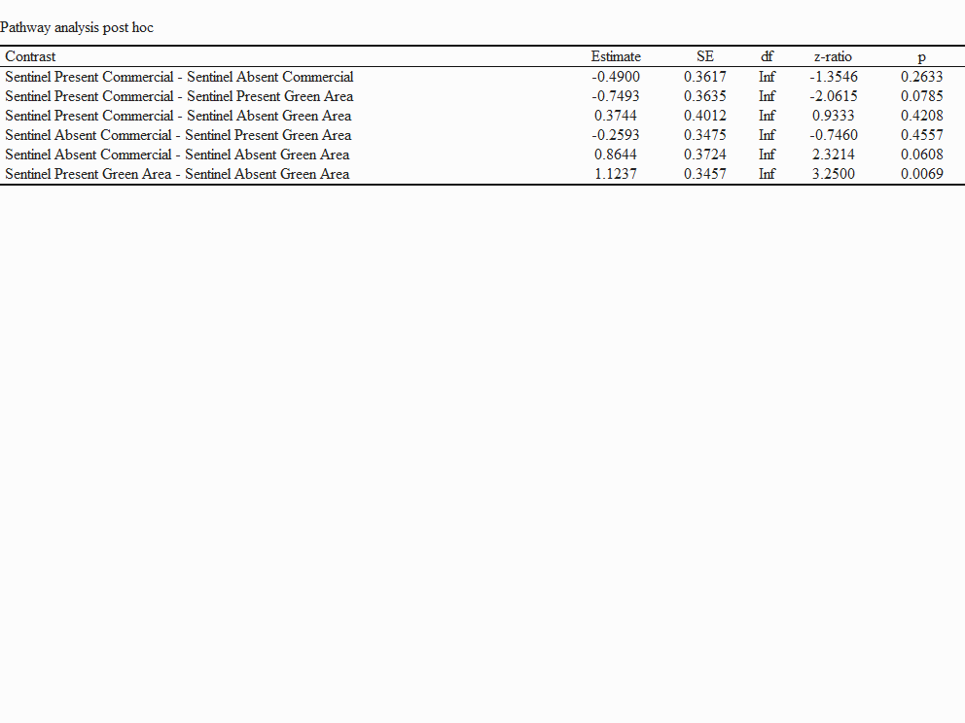

**Appendix**

**Captions**

**Figure A1:** Map of observations from Crowkemon Go (black dots) and sampling locations (large circular icons) used during the data collection phase. The single recurrent site used is in green, with the two failed sites in red. Opportunistic sampling sites are in yellow. Focal area was limited to the St. Catharines region.

**Figure A2:** Frequency plot of the likelihood of a sentinel being present in response to disturbance frequency (left) and group size (right). The y-axis represents the count of videos without sentinels (in orange) and in the presence of a sentinel (blue). The figure demonstrates that there is no evident pattern for the likelihood of a sentinel being present in response to either factor.

**Figure A3:** Dot plot of the duration of bouts of all behavior on disturbance frequency (per min), showing a significant decrease in the duration of bouts as disturbance frequency increased.

**Figure A4:** Dot plot of the mean bout duration of foraging behavior in the presence and absence of bait at the sampling location. The error bars represent the standard error. The average duration of foraging bouts decreased significantly in the presence of bait.

**Figure A5:** Dot plot of the mean number of transitions from one behavior to another in the presence and absence of bait. The error bars represent the standard error. The number of transitions from foraging to alert behaviors are comparatively few, and do not significantly change in the presence of bait. All other types of transition are significantly affected by the presence of bait, significantly increasing in its presence.

**Table A1:** Explanation of generalized environment. Each zone type was identified using the St. Catharines and Niagara zoning maps for each sampling location. The zones were subsequently generalized under the terms “Green” and “Commercial” areas.

**Table A2:**Ethogram of behaviors analyzed during foraging events. The three behaviors are based on the individual’s head position and generally reflect the individual’s ability to be vigilant.

**Figure A1**

**Figure A2**

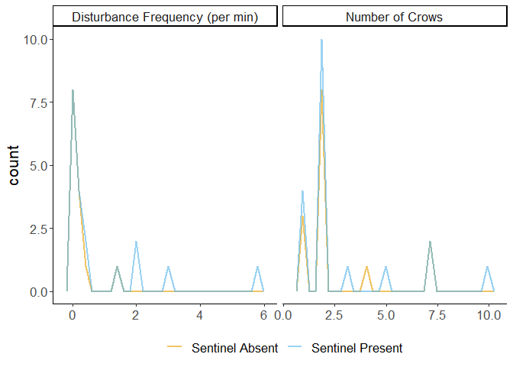

**Figure A3**

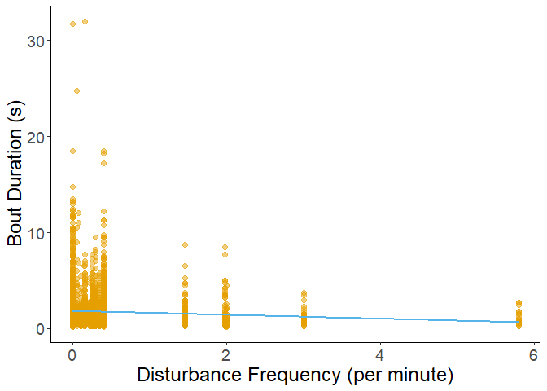

**Figure A4**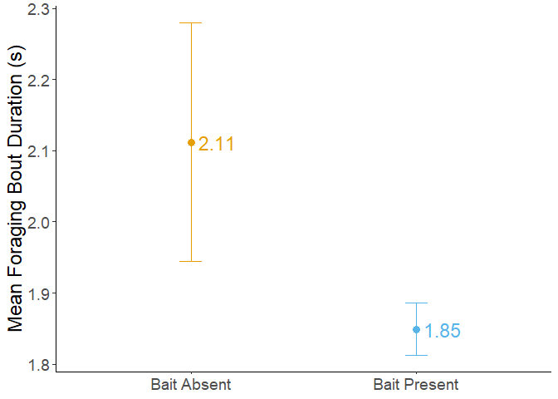

**Figure A5**

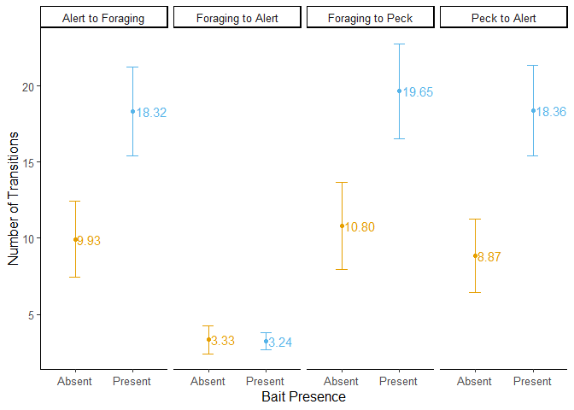

**Table A1**

|  |  |
| --- | --- |
| Generalized Environment | Zones included |
| Commercial Area | Arterial Commercial, Business Commercial Employment, Community Commercial, Major Commercial |
| Green Area | Major Green Space, Minor Green Space |

**Table A2**

|  |  |  |  |
| --- | --- | --- | --- |
| Behavior | Code | Definition | Illustration |
| Foraging | Head Down | Focal individual is stationary and has its head downwards or in a non-upright position, either pecking or handling food, looking for food, or engaging in other behaviors that make vigilance ineffective (e.g. preening). |  |
| Moving | Moving | Focal individual is moving, either by flying, hopping (leaping), or walking. |  |
| Alert | Head Up | The focal individual is stationary and has its head and body in an upright position. Individuals can have a mobile (scanning) or immobile head but must not be looking downwards. Individuals can be handling food. |  |

*All illustrations are under creative commons license (copyright-free)*